**EX:05- Create a simple cloud software application for Library book reservation**

**system for SIMATS library using any Cloud Service Provider to demonstrate SaaS.**

**Aim**

To Create a simple cloud software application for Library book reservation system for SIMATS library using any Cloud Service Provider to demonstrate SaaS.

**Procedure**

* **Login to Cloud Platform** – Sign in to a cloud service provider (Zoho Creator / AWS / Google Cloud / Azure).
* **Create New Application** – Start a new app, either with a blank project or by selecting a template.
* **Design Forms & Modules** – Add forms for student details, book details, reservation requests, and return info. Create reports to display available books, issued books, and reservation status.
* **Set Workflows & Logic** – Automate processes like reservation confirmation, due-date reminders, late-return alerts, and availability checks.
* **Deploy the Application** – Publish the library app on the cloud platform so it runs online.
* **Provide SaaS Access** – Share the application link with SIMATS students and staff so they can reserve/track books anytime as a SaaS service.

**Output**

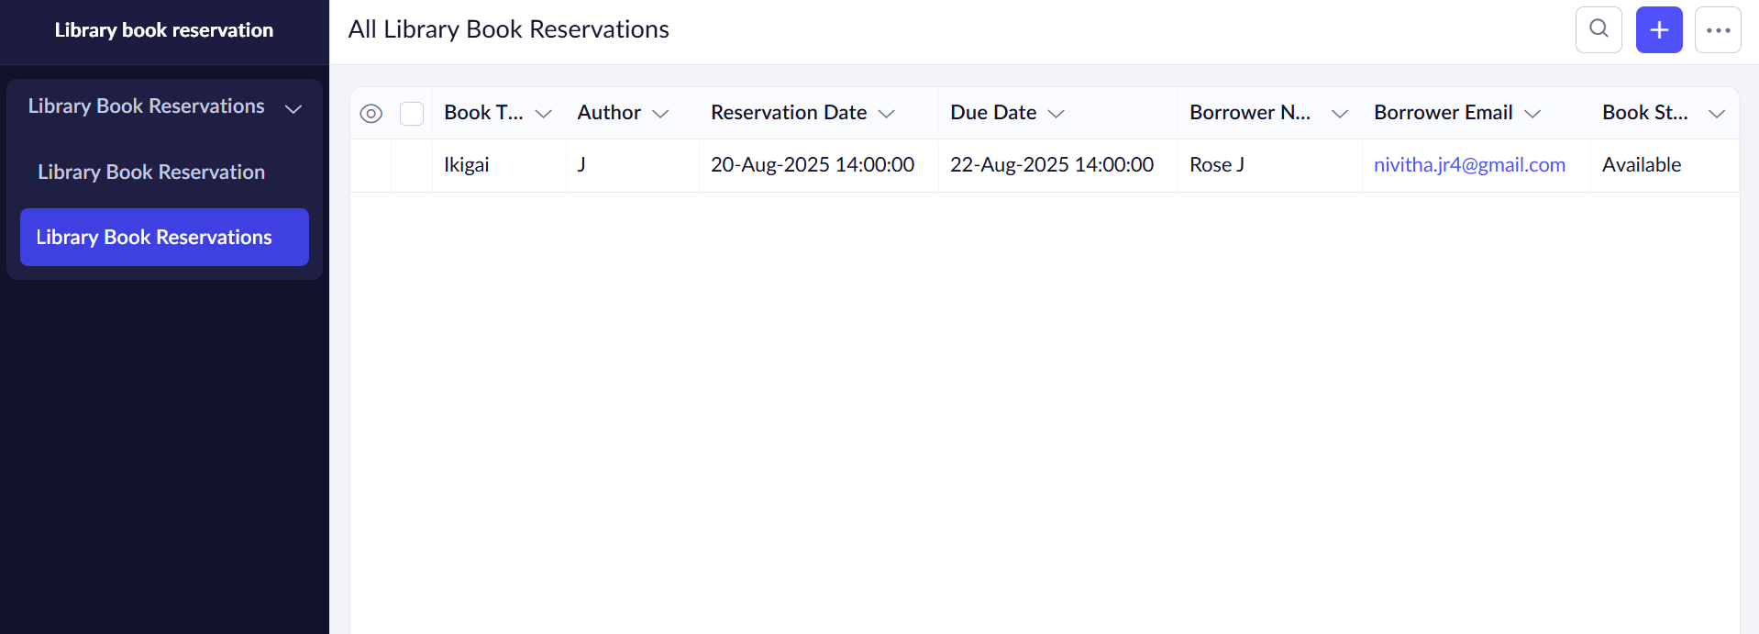

**Result**

Thus, to Create a simple cloud software application for Library book reservation system for SIMATS library using any Cloud Service Provider to demonstrate SaaS was created successfully.